Application for Admission
to WPA’s Scholarship Program
“Integrative solutions for water issues and conflicts”

If you are interested in participating in the WPA group’s Scholarship Program “Integrative solutions to water issues and conflicts” (for details see the announcement at www.water4use.info), please use this application form.

Checklist
of documents to be submitted to WPA

Cover letter signed by the applicant / including a motivation statement

Application form

Scanned copies of all relevant academic and non-academic certificates of degrees and transcripts:
- Master / Diploma degree certificate
  - and Transcript of Records
- Bachelor degree certificate
  - and Transcript of Records
- High School certificate
- TOEFL or IELTS certificate or other English proficiency certificate
(only for foreign applicants)

All certificates must be accompanied by an explanation of the grading system. If the documents are neither German or English an authorized translation is needed in one of those three languages.

Passport photo

Two letters of recommendation (please use the provided form only!)

Please send WPA all documents of your application in one e-mail. None of the attached documents should exceed a file size of 5 MB. Please compile all documents into two PDF files:
- File 1: completed application form;
- File 2: scanned cover letter and scanned copies of all relevant certificates obtained and passport photo;
- the two letters of recommendation should be send by the referees (pdf)
Please name all files in a systematic way: <applicant’s last name – WPA – file number>. To transform the documents into PDF one can download “FreePDF” as freeware.

WPA will confirm the receipt of your application, which my take some days…

Please submit all these documents to water4use@uni-hohenheim.de (only to this mail address!), no later than the announced deadline at the homepage.

We wish all the best for your application!

- Personal Data

Name of the applicant (as indicated in the passport)

Last name:

First name:

Middle name:

Date of Birth (day, month, year): , ,

Place of Birth:

Nationality:

Place of living:

Postal address:

Telephone:

E-mail:

Male Female

Private (residential) address:

Telephone:

- Educational Record
(Start with institution most recently attended and work backwards)

Educational Institution | Location  (City,Country) | Major Field of Study | Name of the Degree & Diploma | Marks Percentage  or GPA* | Years attended  from - to

GPA*: Grade Point Average

- Employment Record:
(List in reverse order, copy-paste if you need more than one)

A. Present or most recent post

Employer:

Address of Employer:

Position held: from (year): to:

Location of posting:

Description of your work, indicating personal responsibilities:

- Computer skills and competencies
(not more than 5)

- Other skills and abilities
(not more than 5)

- Title of Diploma-, Master thesis and submitted to which university:
(Please tick as appropriate)

Thesis title:

Submitted to:

- Abstract of Diploma/ Master thesis:
(Maximum 300 words)

- publications/ conference contributions if applicable:
(max 5 publications)

Title | Co-authors | Journal/conference | Date

- Language / English Proficiency

Mother tongue:
Language(s) used as medium of instruction in secondary school:

Language(s) used as medium of instruction in higher education:

language(s) skills (please indicate the level according to the figure below):

English ( )

Foreign applicants: In order to get the admission of the agricultural faculty for PhD student you must provide a proof that the medium of instruction at your school or university was English, or a certified statement from a recognized authority (e.g. TOEFL: 550, IELTS: 6, British Council) concerning your proficiency in English. You can hand in this proof later in case you are selected for the WPA scholarship. If you cannot verify adequate English language skills, you cannot get the admission by the faculty and your WPA scholarship cannot be awarded.

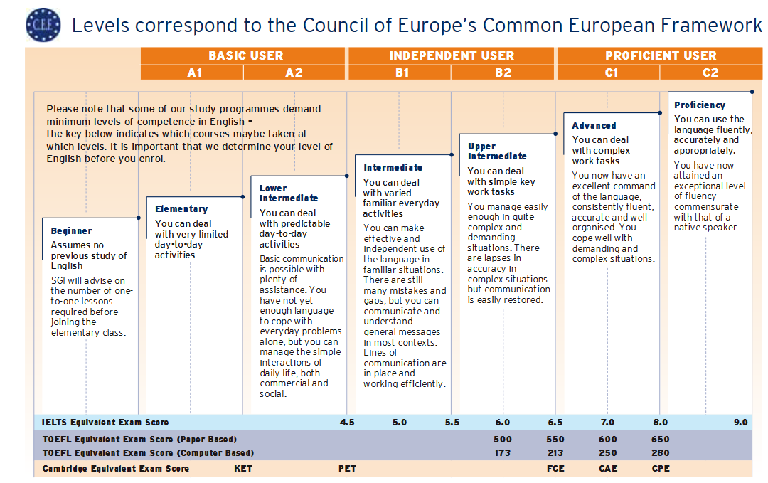

- Research proposal
Please note that your research theme should be in accordance with the conceptual research framework of the “Water – People – Agriculture Research Training Group”. Your research proposal has to relate to ONE of the research themes listed on WPA’s homepage (see “List of research themes” at www.water4use.uni-hohenheim.de).
Applications will only be accepted, if the research proposal is based on ONE of the research themes suggested on the “List of research themes” from WPA’s webpage.

Title of your Proposal:
Related to the research theme on WPA’s Webpage:
(Please repeat the title and give the number of the suggested research theme)
Link of this proposal to applicant´s previous work and studies
(Maximum 200 words)
Summary:
(give a brief summary of your research proposal, maximum 300 words)
Introduction:
(Maximum 300 words)
Objective:
(Maximum 200 words)
Research questions:
(Maximum 200 words)
Methodology:
(Maximum 300 words)
Main activities:
(Maximum 200 words)
Expected results:
(Maximum 200 words)
Thematic link to the objectives of WPA Research Training Group:
(Maximum 200 words)
Work plan:
(please give a brief schedule of your activities during your PhD program)
Estimated budget:
Please provide the detailed description along with full calculations of your proposed budget of the project. Please specify in Euros, but do not include WPA’s scholarship (cost of living, cost for flight to Hohenheim and back). Please indicate the amount you require from WPA (in EUR additional to your scholarship).
Other funding sources:
Please note that WPA is providing only well justified research funding. Therefore it is advisable to seek for additional funding sources to cover the research costs and other additional costs. Please indicate which organization is willing to contribute how much to which part of your research activities.
References:

I do hereby confirm that the information provided above is correct to my knowledge and belief.

/
Date / Place (typed) Signature

